Introduction to Wave Mechanics

Aircraft Carrier Cable System

Team:

Carpe Noctem

Team Leaders:

Jake Tisdale

Team Members:

Carlos Lazo, Christopher Rappa, Jake Tisdale, Michael Sangillo

Course: TDC1 – Introduction to Wave Mechanics

Instructor: Joshua Niedzwiecki

Group Hours: 15 hours

Date Submitted: 11/24/08

INTRODUCTION

A military customer assigns our team, Team Carpe Noctem, with the task of analyzing an aircraft carrier cable system. They ask us to examine a specific section of a cable located on an aircraft carrier where two cables of different diameters are joined. This section is of special interest because the change in diameter causes the vibrating waves traveling through the cable to reflect and transmit different portions of their energy. This setup is seen in Figure 1.

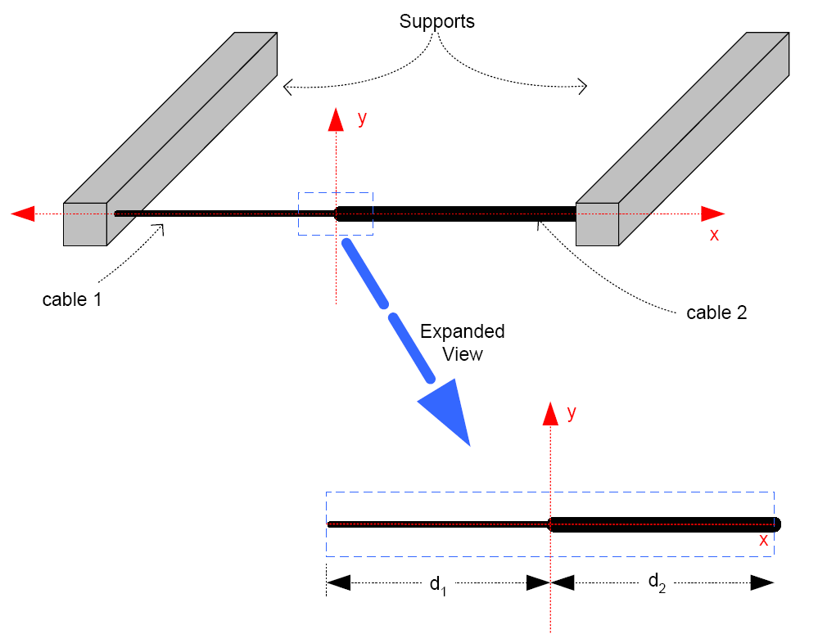

Figure 1: Aircraft Carrier Cable System Diagram

Our customer has requested that we perform an analysis based on three different sets of conditions. At first, we will assume that both cable 1 and cable 2 have the same properties and that the incident waves coming from both ends are equal in amplitude and wavelength. The second condition assumes the customer has the ability to fix a damper between the right support beam and the adjacent cable, effectively eliminating any vibration from that direction. In this costly condition, the cables do not have the same physical properties. The final condition assumes the damper is too expensive, with incident waves arriving from both sides. Both cables in this scenario have different properties.

GENERAL WAVE EQUATION

We begin our analysis by defining our incident waves as specified:
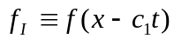
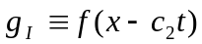

Through analysis and observation of the wave system, it can be seen that the two sides of the general wave equation along the aircraft cable system can be represented as follows:
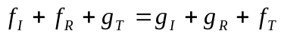
Equation 1

At the point of cable intersection, there exist two conditions which we can use to solve for the general wave equation. For our first set of equations, we know that both sides of the wave equation must be equal at the point where x = 0:

Equation 2

At this same point of intersection, we also say that the slopes from both the left and right cables at the point x = 0 must be equal. The original equation is simplified as follows:

Equation 3

Using Equations 2 & 3, we can rewrite all reflected and transmitted waveforms in terms of both incident waves:
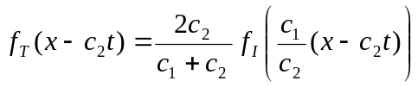 Equation 4
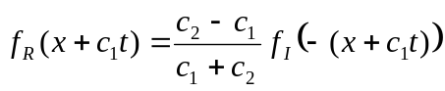 Equation 5
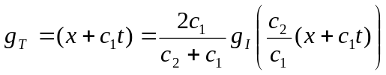 Equation 6
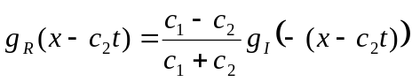 Equation 7

Substituting these values into our initial wave equation, we see the following result for the general wave equation:

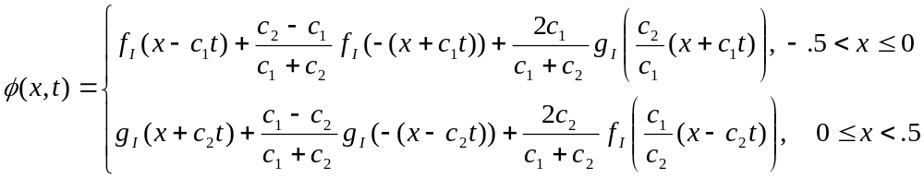
Equation 8
Where c₁ and c₂ are equal to:

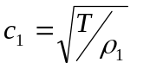
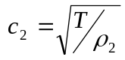

We are given that the beam vibration equation is modeled as the following function:

Through substitution into Equation 8, we arrive at the general form of the wave equation:
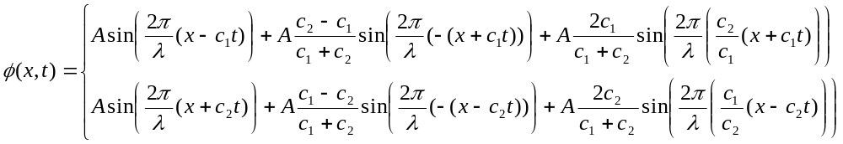
-.5 < x ≤ 0
Equation 9
0 ≤ x < .5
Before analyzing the different conditions, our group decided it would be beneficial to develop a chart of all the coefficient calculations that would be needed.

 | C₁ | C₂ | (C1-C2) (C1+C2) | (C2-C1) (C1+C2) | 2*C1  (C1+C2) | 2*C2  (C1+C2)
Condition 1 |  |  | 0.000 | 0.000 | 1.000 | 1.000
Condition 2 |  | 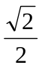 | 1/3 | -1/3 | 4/3 | 2/3
Condition 3 |  |  | 1/3 | -1/3 | 4/3 | 2/3

Table 1 – Coefficient Matrix Calculations

CONDITION 1

In our first condition, the vibration coming from each beam is equal. Also, the values of our C₁ and C₂ variables are equal as seen in Table 1 – Coefficient Matrix Calculations. The tension (T) is known to be 1N with the linear mass densities being 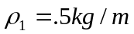 and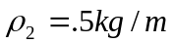.

Using Equation 9 and the known coefficients, we plug in and simplify the equation:

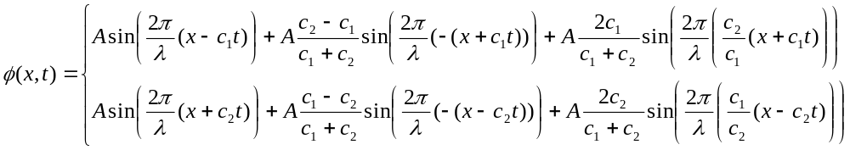
1
1
0
0
1
1
-.5 < x ≤ 0
0 ≤ x < .5
Since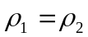, the coefficients associated with this condition are equal. This shows us that there will be no reflection and some transmission seen in the system. Since c₁ = c₂, both parts of the equation end up being equal. The quantity 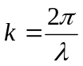is defined as the wave number. Our group rewrites the general equation:
-.5 < x < .5

Using one of the sum-to-product trigonometric identities, we can combine our previous equation:

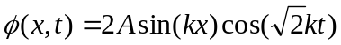
-.5 < x < .5

With k = 20, we substitute into our equation to get the solution of our wave equation for this condition:

-.5 < x < .5
Equation 10

The envelope of this first condition is defined the by the equation:

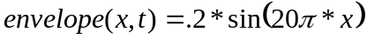
-.5 < x < .5
Equation 11

CONDITION 2

In this second condition of analysis, a damper is built into the right beam system, causing the waves to be nullified. In other words, g(z) = 0. The tension (T) is know to be 1N, and the linear mass densities are given as 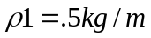 and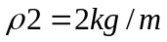.

Using the generic wave formula established in Equation 9, we cancel out all terms involving the incident, reflective, and transmissive waves from the right part of the system. Since g(z)=0, there is no g_{R}, g_{T} or g_{I} in the equation. We simplify the equation algebraically and use trigonometric identities to reduce the formula further:
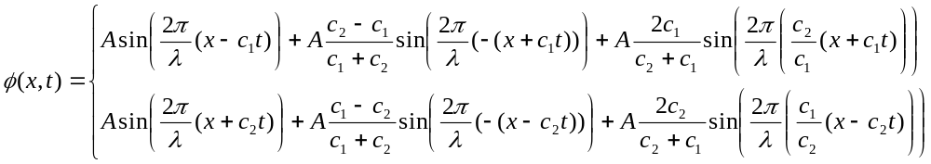
0
0
0
-.5 < x ≤ 0
0 ≤ x < .5

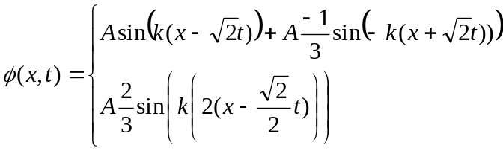
-.5 < x ≤ 0
0 ≤ x < .5

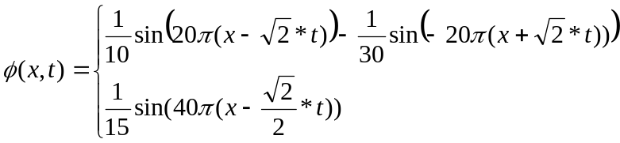
0 ≤ x < .5
-.5 < x ≤ 0

We first find the envelope equation for the first range of x values where -.5 < x ≤ 0. The current sinusoidal expression can be rewritten as a product of cosine and sine:

Equation 12
Our group uses the following trigonometric identity to represent the wave equation in a form where the envelope can be seen:
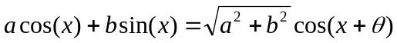, 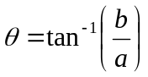 Equation 13

Based on Equation 12, we deduce the coefficients of the previous expression:

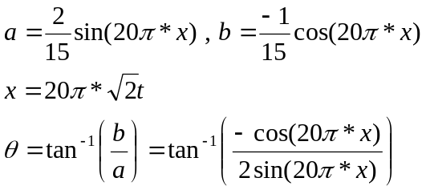

Making all necessary substitutions, we arrive at the following equation:

Knowing that our term is just a phase-offset, we see that the cosine term is our modulator since it varies with respect to time. Therefore, the first term of the equation is our envelope:
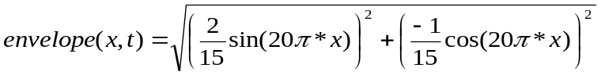
-.5 < x ≤ 0

Equation 14

We then look at the envelope for the wave equation between the range 0 ≤ x < .5. In this region, we know that there only exists a transmitted wave with no reflection due to the absence of an incident wave. Since the transmitted wave is always constant in amplitude, the envelope of this area is defined as the amplitude of the function we derived:

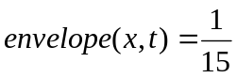
0 ≤ x < .5
Equation 15
Our group was then asked to calculate the linear mass density given that the spatial frequency of the propagating wave in cable section d2 is 1 cycle per meter. Knowing that 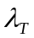is proportionally related to the spatial frequency, our calculation was done as follows:

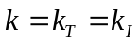
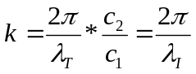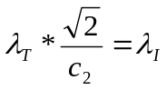
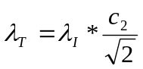
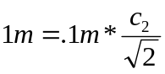
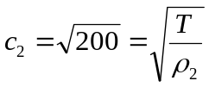
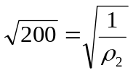
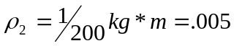
Equation 16

CONDITION 3

With the damper recommendation from Condition 2 being deemed as too expensive, we revert to the original system where the vibrations again coming from both sides of the cable intersection. The vibrations are equal, meaning that f(z) = g(z), and give by the customer as seen in Equation 9. The tension (T) is know to be 1N and further the linear mass densities are given as and. In this case, since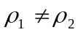, there is reflection seen at the center of the beam system. This implies that at each cable section, all wave components (I/R/T) are taken into account. Using the calculated coefficients from Table 1 – Coefficient Matrix Calculations, we simply substitute into the general wave equation to find the solution:

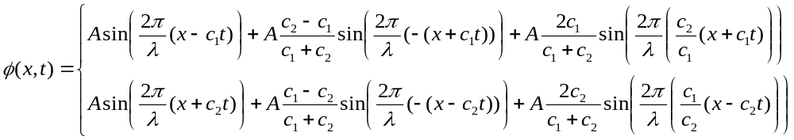

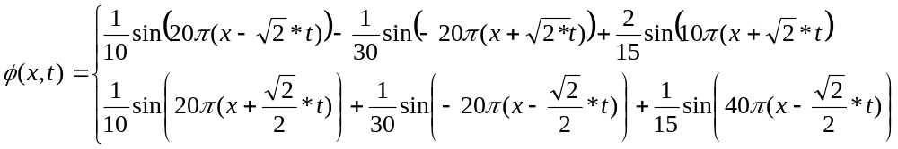
-.5 < x ≤ 0
0 ≤ x < .5

Equation 17

